GREENHOUSE EFFECT SPEAKING ACTIVITY

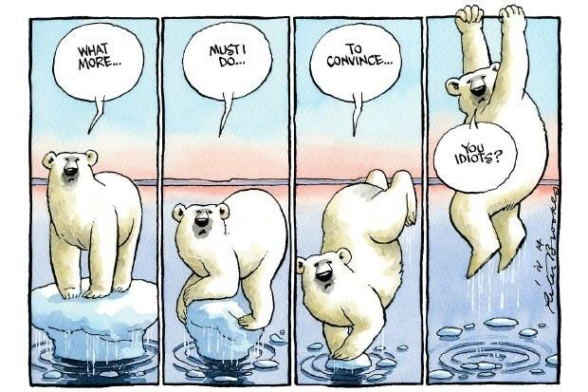
On March 30, 2014, The Times published the picture below, by the cartoonist Peter Brooks.
Think and discuss with a partner what phenomenon the stripe alludes and the message the author wanted to communicate.

THINK - PAIR - SHARE
- Reflect on the question individually
- Find a partner
- Share your ideas with your partner and listen to his own

