PERCENTAGE SPEAKING ACTIVITY

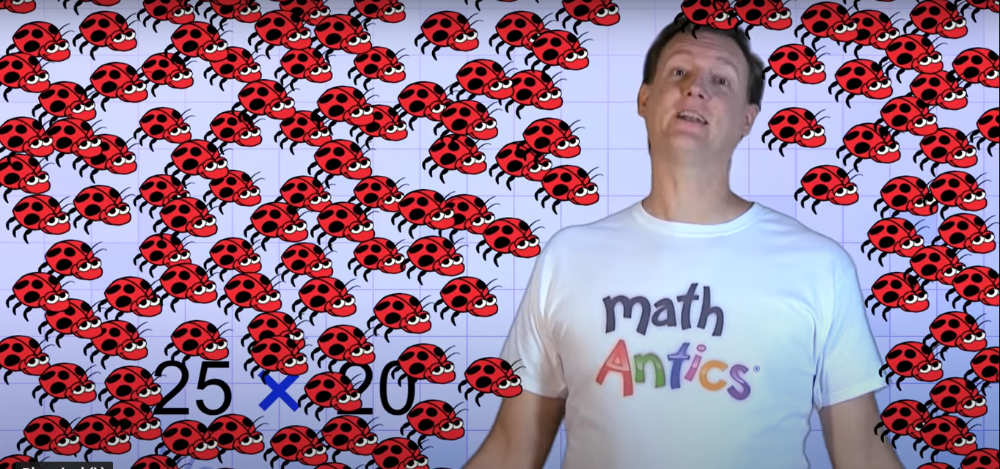
Thy young man in the picture found 20 ladybugs in his garden.
He needs to calculate the 25% of this population and …. You see the result!
Is he right? Think about that and then discuss with your mate. Furthermore, if you wish, you can deepen your knowledge on percentage with a further activity with these ladybugs.
THINK - PAIR - SHARE
- Reflect on the question individually
- Find a partner
- Share your ideas with your partner and listen to his own

