PHOTOSYNTHESIS SPEAKING ACTIVITY

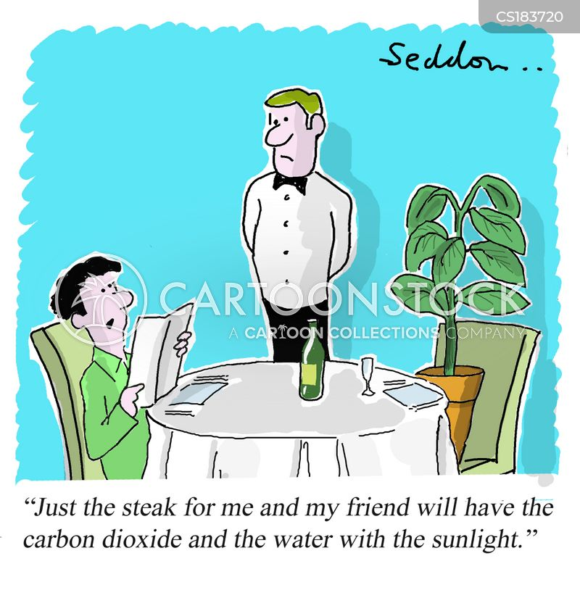
What is going on in the picture below?
Think and discuss with a partner what phenomenon the cartoon alludes to and why it makes you smile.

THINK - PAIR - SHARE
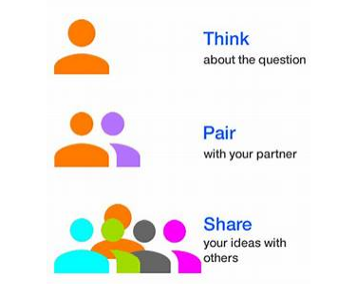
- Reflect on the question individually
- Find a partner
- Share your ideas with your partner and listen to his own

