PLASTIC SPEAKING ACTIVITY
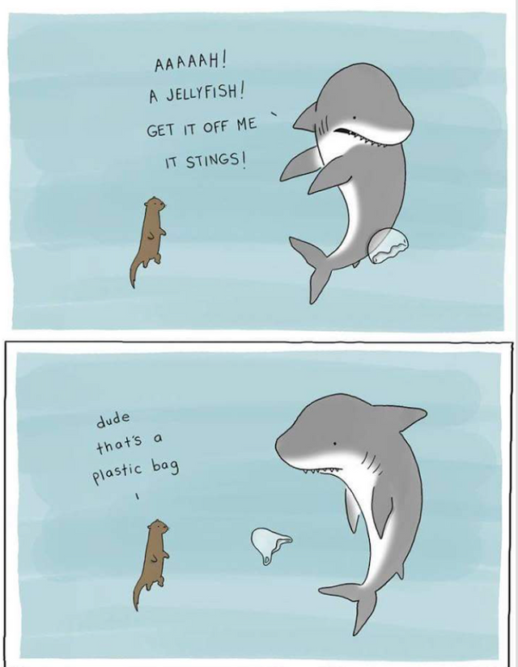
source https://steemit.com/pollution/@alketcecaj/plastics-in-the-ocean-a-meme
Think and discuss with a partner what phenomenon the image below alludes and its meaning.

THINK - PAIR - SHARE
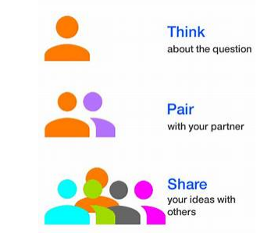
- Reflect on the question individually
- Find a partner
- Share your ideas with your partner and listen to his own

