Exponential Growth

Teaching Resource Part A: Script Reading Exercise

Introduction To The Contents
Hello my name is Dr. Rita Scully and I am a Lecturer at Limerick Institute of Technology in Ireland.
This video is on Exponential Growth.
I will explain what Exponential Growth is and I demonstrating two examples of Exponential Growth using savings and a chessboard example.
Video 2 should be viewed for the Exponential Function.

What You Know
To help you understand Exponential Growth it would help to review some information on: Linear Growth, Power Growth, Formula and Equations
- Linear Growth – something grows by the same amount in each time step
- X³ Growth - growing to a set power, in this case the power of 3, at each interval
- Exponential growth is shown as the green line
- Formula - a concise way of expressing information symbolically.
- Equation: an equation is a statement that says the equality of two expressions.

Introduction
What is Exponential Growth?
This is what this video is going to discuss today. And we will see examples of how it is used in savings, the chessboard example and later you can look at video 2 on Exponential Function.
Exponential growth is growth that increases by a constant proportion. It is a specific way that a quantity may increase over time. It occurs when the instantaneous rate of change of a quantity, with respect to time, is proportional to the quantity itself. Exponential growth is described as a function.
It is used to explain something that always grows in relation to its current value, such as doubling, tripling and so on.

Main Body

Exponential growth
Let’s say I decide to save €0.01 today, and I plan to save twice the total each day; so on day 1 I will be saving €0.01, on day 2 I will be saving €0.02 and on day 3 €0.04.

How much would I have saved by the end of the month?
By day 14 I am at €81.92.
By the end of the month I have saved a lot more.

1  € 0.01 | 2  € 0.02 | 3  € 0.04 | 4  € 0.08 | 5  € 0.16 | 6  € 0.32 | 7  € 0.64
8  € 1.28 | 9  € 2.56 | 10  € 5.12 | 11  € 10.24 | 12  € 20.48 | 13  € 40.96 | 14  € 81.92
15  € 163.84 | 16  € 327.68 | 17  € 655.36 | 18  € 1,310.72 | 19  € 2,621.44 | 20  € 5,242.88 | 21  € 10,485.76
22  € 20,971.52 | 23  € 41,943.04 | 24  € 83,886.08 | 25  € 167,772.16 | 26  € 335,544.32 | 27  € 671,088.64 | 28  € 1,342,177.28
29  € 2,684,354.56 | 30  € 5,368,709.12 | 31 € 10,737,418.24!!
Let’s look at this as a formula
A quantity x depends exponentially on time t if ${}_{}^{}x=a.b^{t}$
a is the amount you begin with in our example 1c
b is the rate of growth in our example twice, it doubles
t is the time that this growth will go on for in our example it was 31 days
So
a = €0.01 b = 2 (it doubles) each day t = number of times it occurs. Let’s see what our savings would be on day 23 it will have occurred 22 times
So our formula would be ${}_{}^{}x=0.01x2^{22}$
${}_{}^{}x=€ 41,943.04$ on day 23 of our savings

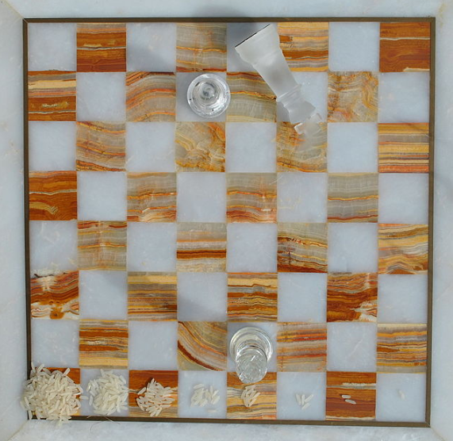
Another example that is often used is Rice on a chess board. On the first square one grain of rice is placed, then its current value is doubled so 2 grains of rice on the second square, its current value is doubled 4 grains of rice on the third square.
There are 64 squares on a chess board so using the formula.
How much rice will be on the last square?
Even a guess to the closest billion??
Our formula is: ${}_{}^{}x=a.b^{t}$
In this example a = 1 b = 2 (it doubles) each square t = number of squares 64 in this example
${}_{}^{}x=1x2^{64}$
${}_{}^{}x=18,446,744,100,000,000,000$
eighteen quintillion, four hundred forty-six quadrillion, seven hundred forty-four trillion, one hundred billion grains of rice.

What You Have Learned
Exponential growth is growth that increases by a constant proportion.
Exponential growth is described as a function.
It is used to explain something that always grows in relation to its current value, such as always doubling.
A quantity x depends exponentially on time t if
${}_{}^{}x=a.b^{t}$ where
a is the amount you begin with
b is the rate of growth
t is the time this growth will go on for
Exponential growth can be used in mathematics, biology, chemistry and finance.

Teaching Resource Part B: Glossary
Equation: an equation is a statement that says the equality of two expressions 1

Exponential Function: is growth that takes place on a continuous basis. It is a specific form of Exponential Growth 1

Exponential Growth: growth that increases by a constant proportion in relation to its current value 1

Formula: a concise way of expressing information symbolically 1

Linear Growth: something grows by the same amount in each time step 1

Power Growth: growing to a set power at each interval 1

Teaching Resource Part C: Multiple Choice Quiz

The Quiz is available on wordwall.net in an interactive format and also as a downloadable pdf. https://wordwall.net/resource/3219434

