Introduction To The Contents
Hello my name is Dr. Rita Scully and I am a Lecturer in Limerick Institute of Technology in Ireland.
This video is on Percentages. I will introduce and explain Percentages and how to use them. I will show how to use Percentages in real-world examples

What you Know
To help you understand percentages it would help to review some information on fractions and also on decimals
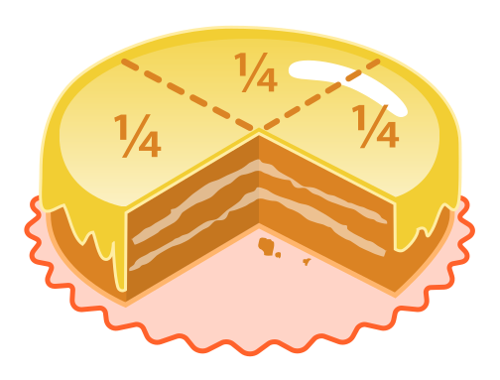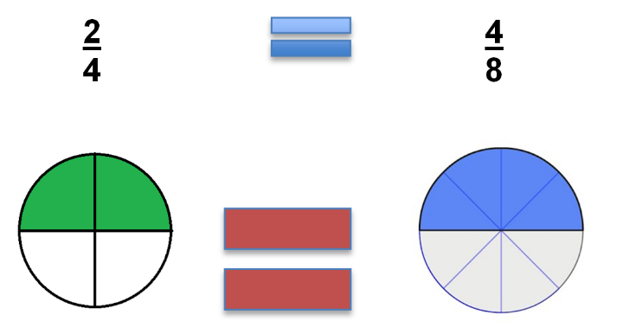
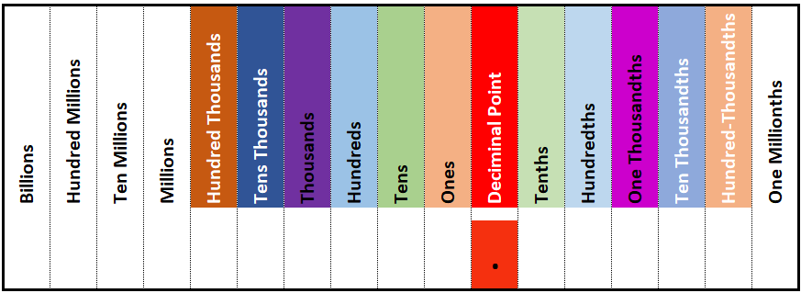

Key Words
In this video there will be some key words introduced
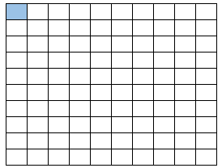
Percentages - the whole of something represented in one hundredth parts
Percent (or per cent) - means one per one hundredth.

One hundredth - something divided in one hundredth parts
Fractions - a mathematical representation of a portion of something and is a quantity that is not a whole number
Fractional parts - two parts – the numerator (top element) and denominator (bottom element)
$$\frac{1}{100}=\frac{numerator}{denominator}$$

Decimal – A decimal is a number expressed in the scale of tens.

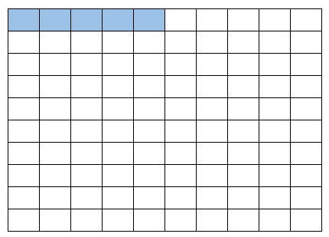
Introduction
The symbol for percent is %
So, 1% means 1/100 or one hundredth, and 5% means 5/100 or five hundredths.
Since percentages are the whole of something represented in one hundredth parts this means they are fractions.
Because fractions represent a portion of something they can be used in any situation where quantities need to be classified into parts, or measured, or quantified.

Main Body
In understanding percentages, it helps to imagine the whole being broken into 100 parts.
Percentages are similar to fractions and decimals, they are another way of writing fractional parts.
But they always give the number of parts out of 100.
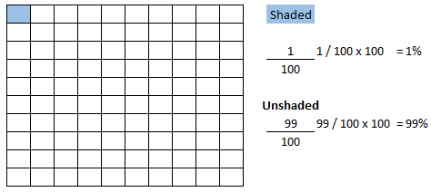
1 is shaded out of 100
1/100 or 1%
99 are unshaded out of 100
99/100 or 99%
So it is important to know what 100% refers to each time.
Percentages are used to give a common standard
Can you think of some uses for percentages?
They are used in many daily applications including
- Bank interest rates,
- VAT (Value Added Tax),
- Discount rates,
Examples
Some examples
What is 5% of €250.00?
$$\frac{5}{100} x 250$$
0.05 x 250 = €12.50

What is 21% of €130.00?
$$\frac{21}{100} x 130$$
0.21 x 130 = €27.30

Real World Examples
Percentages can be used for comparison, for example, the discount that I will get in the sale in comparison to the full original price.
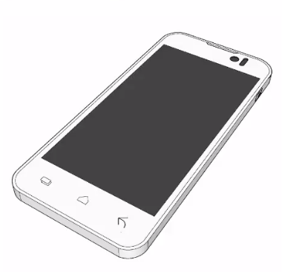
A Phone costs €185.00 but in the January sales it will be reduced by 15%.
How much will the phone cost in January?

To look at this from a maths point of view the cost of the phone will be:

€185.00 less the discount 15%

15% of €185.00

$$\frac{15}{100} x 185$$
0.15 x 185 = €27.75

So the phone will cost €185.00 – the discount €27.75 = so in January the phone cost will be €157.25

We can also calculate a percentage increase.
For example there may be a local effort to get more people to cycle or walk to work or school.
Let’s say in a town of 110,000 people, 75,000 travel to work/school each day. Currently 12% walk or cycle. It is hoped that this would increase to 20%.
So how many people currently walk or cycle and how many people will this increase too.
12% is
$$\frac{12}{100} x 75,000$$
0.12 x 75,000= 9,000 people currently walk or cycle to work or school

20% is
$$\frac{20}{100} x 75,000$$

0.20 x 75,000= 15,000 people may in the future walk or cycle to work or school
This would be an increase of 6,000 people.
Knowing this type of information allows infrastructure and facilities to be planned in advance.

What you have learned
Percent (or per cent) means per one hundredth.
Since percentages are the whole of something represented in one hundredth parts this means they are fractions.
The symbol for percent is %
Percentages are similar to fractions and decimals, they are another way of writing fractional parts.
But they always give the number of parts out of 100.
Percentage calculations can be used as increases or decreases.

Glossary
common standard: a single set of standards, 100 parts, is used throughout 3
Decimal: A decimal is a number expressed in the scale of tens 2
Fractional parts: two parts – the numerator (top element) and denominator (bottom element) 2
$$\frac{1}{100}=\frac{numerator}{denominator}$$
Fractions: a mathematical representation of a portion of something and is a quantity that is not a whole number 2
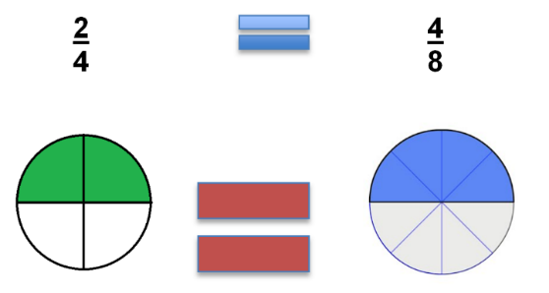
One hundredth: something divided in one hundredth parts 2
Percent: (or per cent) - means one per one hundredth 2
Percentages: the whole of something represented in one hundredth parts 1

