Introduction To The Contents
Hello my name is Dr. Rita Scully and I am a Lecturer in Limerick Institute of Technology in Ireland.
This video is on Probability.
I will introduce and explain Probability and how to use it. I will show how to apply Probability in real-world examples.

What You Know
To help you understand probability it would help to review so information on fractions and also some information on decimals.
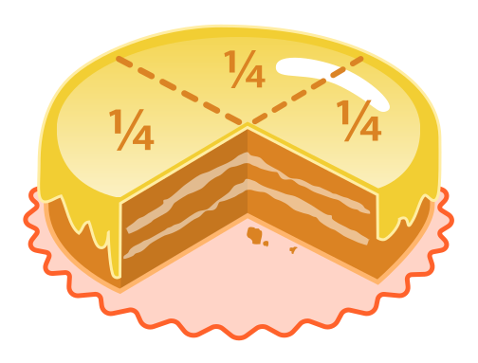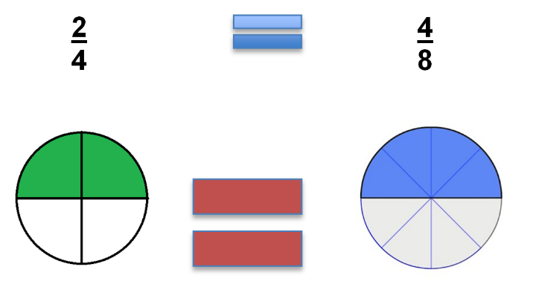
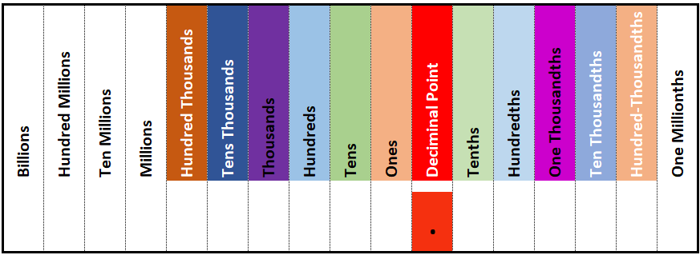
You should also know what a formula is. A formula is a concise way of expressing information symbolically.

Key Words
There are some key words that will be used in this video on Probability.
Probability: Is the study of how likely something is to happen.
Experiment: This is the repeatable procedure or event with a set of possible results.
Outcome: This is the possible result of an experiment.
Sample Space: These are all the possible outcomes of an experiment.
Sample Point: This is just one of the possible outcomes of an experiment. The sample space is made up of all the sample points.
Event: This is just one or more outcomes of an experiment.

Introduction
Whenever we're unsure about the outcome of an event, we talk about the probability of a certain outcome—how likely they are to occur.
Probability is the numerical description of how likely an event is to occur or how likely it is that a suggestion is true.
Probability works on a scale of 0 – 1
0 = The event cannot occur under any circumstances.
1 = The event is certain to occur.
Probability can be shown on the probability line
Main Body
Probability does not tell us exactly what will happen, it is just a guide.
Lets use some of our key words now.
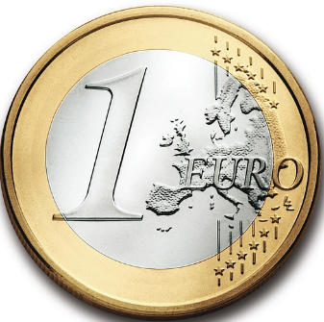
Experiment: To toss a coin.
Outcome: Getting a Heads.
Sample Space: is Heads or Tails.
Sample Point: Getting a Heads or Tails
Event: To toss a Head

This is written as $\frac{1}{2}$
one chance of getting a Head and two possible outcomes; Heads or Tails.
This could also be referred to as 0.50 or 50%.
It’s often referred to as an even chance. 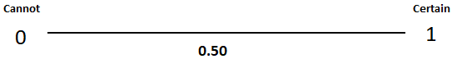
The formula for probability is
The event = the number of ways an event can occur over the number of possible outcomes.

$P \left(event\right)=\frac{Number of ways the event can occur}{The Number of Possible outcomes}$

Real World Examples
Can you think of examples of where we use Probability?
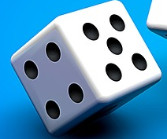
If we consider a six sided dice. Each number has an equal chance of appearing when the dice is thrown.
If we consider the probability of throwing a 4.
We write this as $P \left(Throwing a 4\right)=\frac{1 way of the event can occur}{6 Possiable outcomes}$
probability of throwing a four is $\frac{1}{6}$ or 0.16.
This can be shown on the probability line.

Let’s look at the probability of throwing an odd number.
We write this as $P \left(Throwing an odd number\right)=\frac{3 ways of the event can occur}{6 Possiable outcomes}$
1,3 or 5
So the probability of throwing an odd number is $\frac{3}{6}$ $\frac{1}{3}$ or 0.33.
again this can be seen on the probability line.

Probability can also assess the risk of something NOT occurring.
Let’s look at the probability of NOT throwing a 3.
This can be written as $P \left(Not throwing a 3\right)=\frac{5 ways the event can occur}{6 Possiable outcomes}$
So the probability of not throwing a 3 is $\frac{5}{6}$ or 0.83.

Again this can be seen on the probability line.
Can you think of more examples of where we can use probability?
Probability theory is applied in everyday life in risk assessment and modelling of potential events or outcome.
The insurance industry and financial markets use probability in determining the risk level of an event.

What you have learned
Probability is the study of how likely something is to happen.
Probability works on a scale of 0 – 1
0 = The event cannot occur under any circumstances.
1 = The event is certain to occur.
Probability can be shown on the probability line.
Glossary
decimals: A decimal is a number expressed in the scale of tens 1
Event: This is just one or more outcomes of an experiment 2
Experiment: This is the repeatable procedure or event with a set of possible results. 1
formula: is a concise way of expressing information symbolically 1
fractions: a mathematical representation of a portion of something and is a quantity that is not a whole number 1
Outcome: This is the possible result of an experiment 2
probability line : is a line that shows probabilities and how these probabilities relate to each other 2
Probability: Is the study of how likely something is to happen 1
Sample Point: This is just one of the possible outcomes of an experiment. 2
Sample Space: These are all the possible outcomes of an experiment 2

