Worksheet 1 - Probability Name : ________________

Try these calculations of probability. Explain how you obtained your answer in English
Roll a die and get a number greater than six | 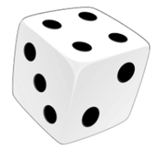
Roll a die and get an even number | 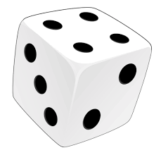
Roll a die and get 3
Pick an ace from a regular deck of cards.
Pick a red card from a regular deck of cards | 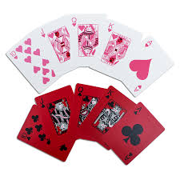
Pick a blue marble from a bag of green marbles

