Addition Reactions of Ethene: The Movie
What do you know?
You should have watched the video on Hydrocarbons.
You should be able to describe what an addition reaction is and describe the mechanisms for addition reactions of ethene with different reagents.
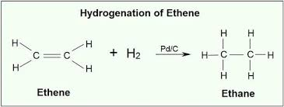
What should you do now?
You are going to make your own movie to explain how ethene reacts by addition with each of these molecules: Hydrogen, Bromine, Water, Hydrogen Chloride.
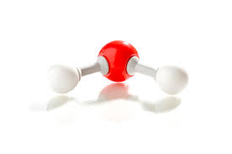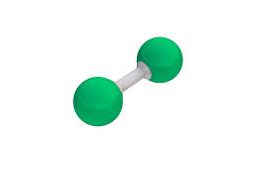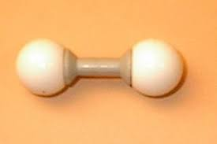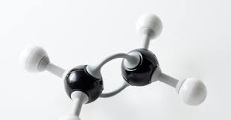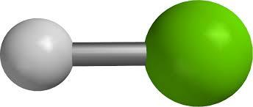
What do you need:
- Molecular models and modelling clay (playdough or plasticine)
- Coloured paper
- Marker pens
- Your mobile phone camera
- *Movie Maker app or Screencastomatic (or similar)

What should you do?
1. Make models of ethene, hydrogen, bromine, water, hydrogen chloride.
2. Storyboard your movie: five or six scenes that would be assembled to form the animation.
3. Prepare a commentary.
4. Construct each scene using sketches, modelling clay, molecular models, or anything else suitable.
5. Take photos of each scene with your camera phone.
6. Import the photos into Windows Movie Maker (free software) and produce the animation. Use with your commentary.

What else can you do? You could:
- Upload your movie to you tube and edit with EdPuzzle. Use it to test your own knowledge and that of your friends.

*https://www.microsoft.com/en-us/p/movie-maker-10-free

