PLASTIC SPEAKING ACTIVITY

Source: https://www.memecreator.org/meme/lets-drink-tea-or-plastic/
Think and discuss with a partner what phenomenon Kermit the Frog alludes and the message the author wanted to communicate through humor.

THINK - PAIR - SHARE
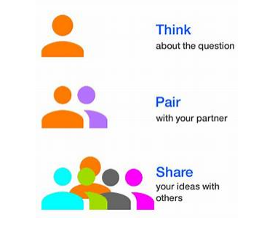
- Reflect on the question individually
- Find a partner
- Share your ideas with your partner and listen to his own

