TRICK OF THE LIGHT SPEAKING ACTIVITY

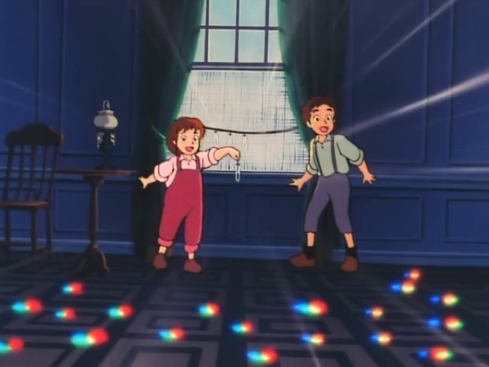
What is going on in the picture below? It is from the cartoon Pollyanna.
Watch the scene from the original movie to find out more. Then think and discuss with a partner where do those colored lights on the floor come from. Try to answer the following three questions one at a time.
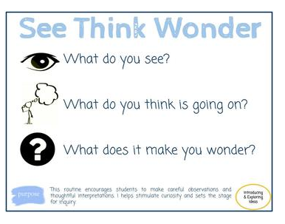
Reflect on the questions individually. Then find a partner to share your ideas with and listen to their own. Repeat at each question before moving on to the next one.

