Physical Properties of Metals: A Kitchen Investigation of Iron in Breakfast Cereals

What do you know?
You should have watched the videos on physical and chemical properties of metals.
You should be able to name three metallic elements that are magnetic.

What should you do now?
You are going to try an experiment in the kitchen at home. This will investigate whether breakfast cereals contain iron – one of the three magnetic elements.
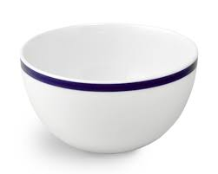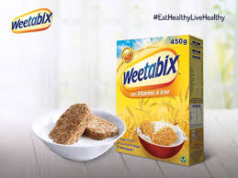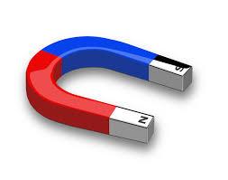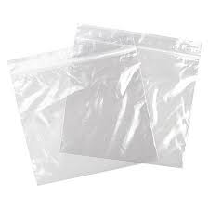
What do you need:
- A kitchen bowl
- Some breakfast cereal that is fortified with iron
- A magnet in a plastic sandwich bag
- A piece of white card

What should you do?
1. Pour the breakfast cereal into kitchen bowl.
2. Put the magnet inside the sandwich bag.
3. Hold one end of the bag-wrapped magnet and use it to stir the cereal. Stir for a minute or two.
4. Remove the bag-wrapped magnet and hold it over the sheet of card.
5. Take the magnet out of the bag and shake the bag gently over the card.
6. Tiny grey particles should fall on the card.
7. Carefully lift the card. Put the magnet underneath it and move it around under the particles. Are the particles attracted to the magnet?

What else can you do?
Many breakfast cereals contain pure iron. Some cereals are fortified with iron to make them more nutritious. Our bodies need iron so that haemoglobin in our red blood cells can carry oxygen.
You could:
- Measure the cereal carefully and measure how much iron you extract.
- Compare the amount of iron in different cereals.
- Compare your results with those of your classmates.

