Our Plastic World: The Leakproof Bag Investigation of Polymers

What do you know?
You should have watched the video on Our Plastic World.
You should be able to describe what a polymer is.

What should you do now?
You are going to try an experiment in class or in the kitchen at home. You will investigate what happens when a bag half-filled with water has some pencils pushed into it.
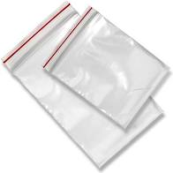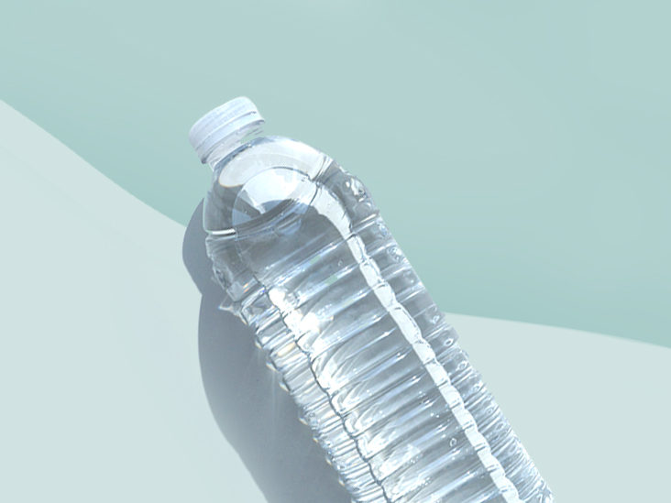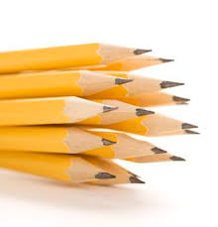
What do you need:
- A Ziplock bag
- Some pencils that have been sharpened to a very sharp point
- Some water
- A sink to practice over (in case things go wrong!)

What should you do?
1. Sharpen the pencils until all the tips have very sharp points.
2. Half fill the bag with water and carefully seal the top.
3. Hold the pencil in one hand and the top of the bag in the other hand.
4. Push the pencil right through one side of the bag and halfway out the other side without spilling a drop. Be careful: do not push any pencils all the way through.
5. Push through more pencils. Try it: over the sink the first time and then over your friend’s head (just for fun).

What is happening?
The long chains of polymer molecules that make up the bag magically seal back around the pencil and prevent water from leaking out.

What else can you do?
You could:
- Compare the results when you use different thicknesses of bags.
- Compare the results when you use different shapes of pencil. Guess which shape would be best?

