Probability Exercises Worksheet 2 Name : ________________

A box contains 4 triangles, 5 squares and 7 circles.

A single object is drawn at random from the container.

Calculate the probability of the following:
The object is not a circle | 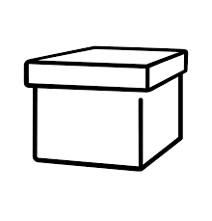
The object is a triangle | 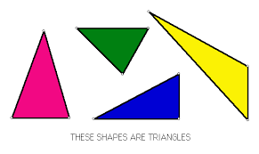
The object is not a triangle
The object is not a square
The object is a circle
The object is a square

Probability Exercise Worksheet 2 Answers

A box contains 4 triangles, 5 squares and 7 circles.

A single object is drawn at random from the container.

Calculate the probability of the following:
The object is not a circle | Total number of objects = 4 + 5 + 7 = 16  $$9/{16}$$
The object is a triangle | $4/{16}$ $1/4$
The object is not a triangle | ${12}/{16}$ $3/4$
The object is not a square | $${11}/{16}$$
The object is a circle | $$7/{16}$$
The object is a square | $$5/{16}$$

