Exponential Function

Introduction To The Contents
Hello my name is Dr. Rita Scully and I am a Lecturer at Limerick Institute of Technology in Ireland.
This video is on Exponential Function.
I will introduce and explain what Exponential Function is and I will be demonstrating 2 examples of exponential function in bacterial growth and financial investment.

What You Know
To help you understand Exponential Function it would be useful to review Video 1 on Exponential Growth.
It would also assist to review
- Linear Growth – something that grows by the same amount in each time step
- X³ Growth - growing to a set power, in this case the power of 3
- And exponential growth from video 1
You should also review
- Formula - a concise way of expressing information symbolically.
- Equation: an equation is a statement that says the equality of two expressions

Introduction
Exponential function is growth that takes place on a continuous basis. It is a specific form of Exponential Growth.
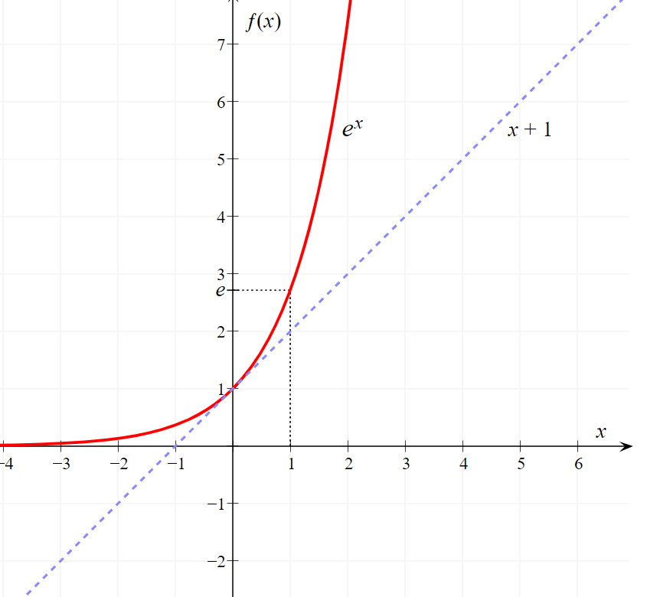
Here we can see linear growth as the blue line and the growth under exponential function as the red line.

Main Body
Exponential Function is usually described as a special function. You are probably familiar with the infinite number π 3.14159265...
With exponential function we will be working with another infinite number e
e = 2.718281828459045... and on
Exponential Function represents continuous 100 % growth
- Continuous is the key phrase.
- If you graph e it has the property that its slope is its value
So for 100% growth it can be written as
$${y= e}^{x}$$
But X is really the rate x time.
$${y= e}^{r.t}$$
As the rate is usually 100% we do not see that but it is important to bear that in mind. It will be applied in later examples.
Here we can see the graph of exponential function versus linear growth.
Where do you think you might see examples of the exponential function occurring?
100% continuous growth. Where might that occur?

Real World Examples : Bacterial Growth
The exponential phase of growth in bacteria is a pattern of balanced growth where all the cells are dividing regularly, and are growing at geometric progression. The cells divide at a constant rate depending upon the composition of the growth medium and the conditions for incubation. The rate of exponential growth of a bacterial culture is expressed as generation time.
Here we will be using the exponential function
Generation time (G) is defined as the time (t) per generation (n = number of generations). Hence, G=t/n is the equation from which calculations of generation time come.
This is an example where the formula of exponential function is used:
$${y= e}^{r.t}$$
is applied
If we start with one cell, when it divides, there are 2 cells in the first generation, 4 in the second generation, 8 in the third generation, and so on. The generation time is the time interval required for the cells or population to divide.
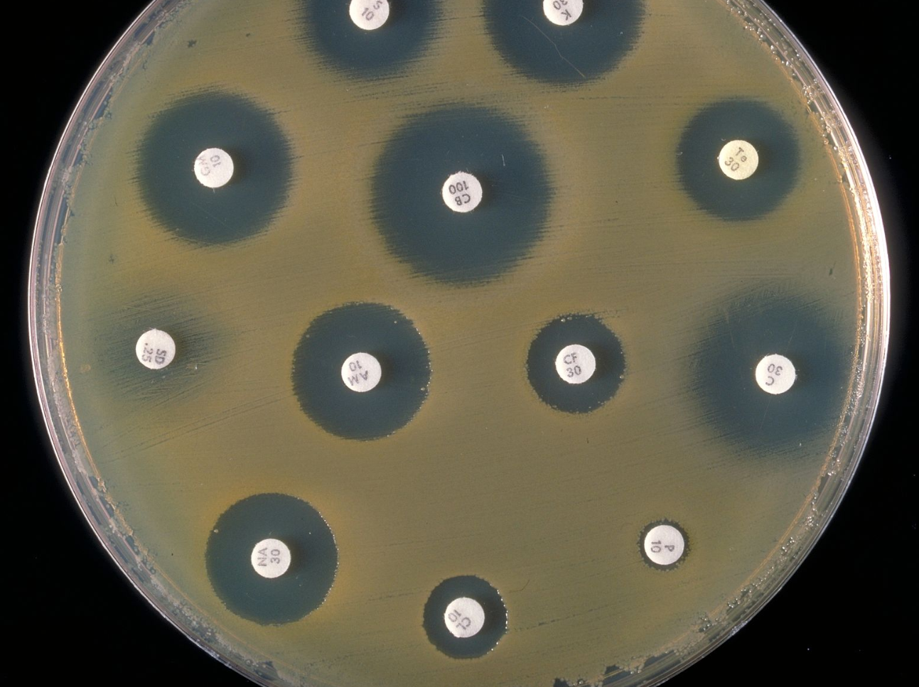

Compound Interest:
Can you think of another example where exponential function can be used?
Let’s look at an example of compound interest for financial growth. If I decided to deposit €1,000.00 for 5 years at a yearly rate of 3%. How much will I have at the end of 5 years?
My formula is
$${y= e}^{r.t}$$
e = 2.718281828…..
the rate is r = 3% = 0.03
the time is t = 5 years 5
so ${y=\left(1000\right)x 2.718281828 }^{0.03 x 5}$

$${y=\left(1000\right)x 2.718281828 }^{0.15}$$

So y = €1,161.83

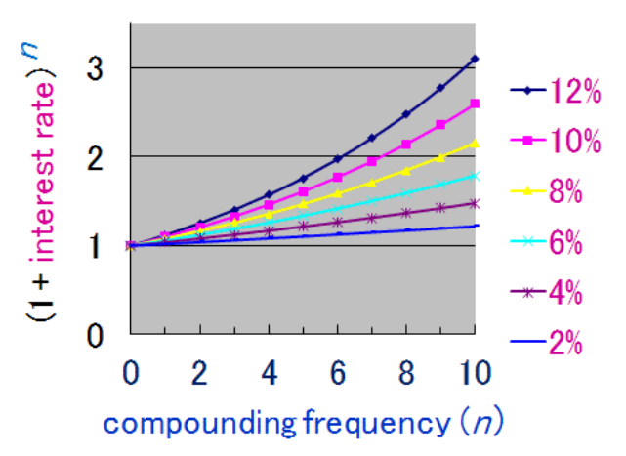

What You Have Learned
Exponential function is growth that occurs on a continuous basis. It is a specific form of Exponential Growth.
It is used to explain something that always grows in relation to its current value.
The Exponential Function is
$${y= e}^{r.t}$$
e = 2.718281828…..
r = the rate
t = time over which the growth will occur
Exponential function can be used in biology, chemistry and mathematics.
Glossary

compound interest: is interest calculated on the initial principal, which also includes all of the accumulated interest from previous periods on a deposit or loan 4
continuous : without interruption 2
Equation: an equation is a statement that says the equality of two expressions 1
Exponential Function: is growth that takes place on a continuous basis. It is a specific form of Exponential Growth 1
Exponential Growth: growth that increases by a constant proportion in relation to its current value 1
Formula: a concise way of expressing information symbolically 1
Generation time: (G) is defined as the time (t) per generation (n = number of generations). G=t/n 3
geometric progression: a progression of numbers with a constant ratio between each number and the one before (e.g. 1, 3, 9, 27, 81) 3
infinite number: is a number so big, that it is impossible to physically write it 2
Linear Growth: something grows by the same amount in each time step 1
X³ Growth: Power Growth growing to a set power at each interval 1

