Our Plastic World: Making Plastics in the Kitchen

What do you know?
You should have watched the video on Our Plastic World.
You should be able to describe what plastic is.

What should you do now?
You are going to try an experiment in class or in the kitchen at home. You will investigate how to make a simple plastic from simple household ingredients you have in your kitchen.
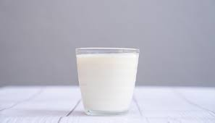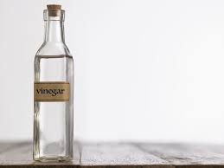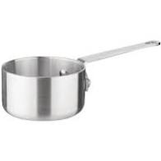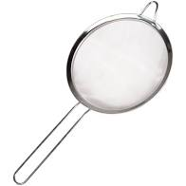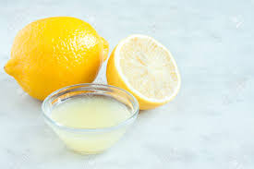
What do you need:
- 1 cup of whole milk or heavy cream, fatter is better
- Vinegar or lemon juice
- Saucepan
- Strainer
What should you do?
1. In the saucepan, heat the milk gently and bring it just to a simmer. Be very careful not to boil the milk as the reaction will not work if you do. **Be careful with heat**
2. Add the vinegar a few tablespoons at a time, stirring with a spoon until the milk starts to separate into solids and liquids.
3. Remove from the heat and pour the milk through the strainer when it is cool enough to handle.

What is happening?
The rubbery and soft stuff in the strainer is the "milk plastic," called casein, an essential part of cheese-making. Harden the plastic by freezing. See how your plastic stuff reacts when pinched, stretched, or dropped. If you let it sit for a while, or put it in the freezer, it will get hard.

What else can you do? You could:
- Pour it into ice cube trays or other shapes and allow it to harden in a fun shape. You could also paint it to make holiday ornaments or natural jewellery as a fun project.
- The plastic will be good for a few days but has the basic shelf-life of food. Throw it away before it becomes mouldy.

