Greenhouse Effect: A simple Investigation

What do you know?
You should have watched the video on The Greenhouse Effect.
You should be able to describe what the Greenhouse Effect is.

What should you do now?
You are going to try an experiment in class or at home. You will investigate what happens when an extra layer of plastic is wrapped around a container of water.
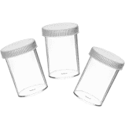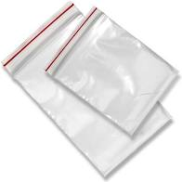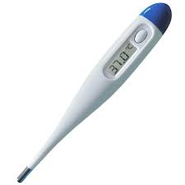
What do you need:
- Two identical glass jars
- 4 glasses cold water
- 10 ice cubes
- One clear plastic bag
- Thermometer
What should you do?
- Take two identical glass jars each containing 2 glasses of cold water.
- Add 5 ice cubes to each jar.
- Measure the temperature of the water in each jar.
- Put the plastic bag over one of the jars (this is the greenhouse glass).
- Leave both jars in the sun for one hour.
- Measure the temperature of the water in each jar.

What is happening?
In bright sunshine, the air inside a greenhouse becomes warm. The greenhouse glass lets in the sun's light energy and some of its heat energy. This heat builds up inside the greenhouse. Write a paragraph describing what has happened using the title ‘Greenhouse Effect’.

What else can you do?
You could:
- Find out what happens if you leave the jars out for two hours, three hours, etc.

