Refraction: A Simple Demonstration Experiment
What do you know?
You should have watched the videos on Reflection and Refraction and Lenses.
You should be able to describe what Refraction is.

What should you do now?
You are going to try an experiment in class or in the kitchen at home. You will investigate a simple example of Refraction.
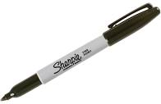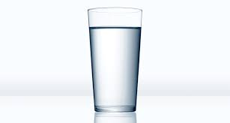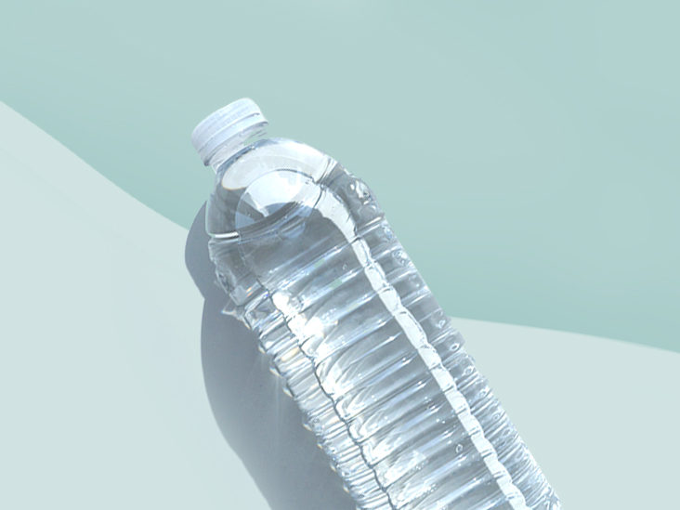
What do you need:
- Piece of Paper
- Marker
- Glass
- Water

What should you do?
1. Take the piece of paper and use the marker to draw two arrows on it. Draw one arrow near the top and one arrow near the bottom of the page. Make the arrows point in the same direction.
2. Fill the glass with water.
3. Slowly lower the piece of paper behind the glass of water.
4. Look through the glass of water and watch what happens.
5. Is it a magic trick?

What is happening?
In the experiment the light travels from the image through the air, then through the glass cup into the water, and finally out of the glass cup and into the air once more before it reaches your eyes. Light refracts as it passes from one medium to the next because it travels at different speeds through those media. Light travels fastest through air, a little slower through water, and even slower through glass. This means that the light bends once when it travels through the glass cup into the water, and then it bends again when it travels out of the glass cup and into the air. As a result, the light paths cross and the image appears to be flipped horizontally (left/right).

What else can you do?
You could: Explain to your classmates what is happening. Give a simple definition of Refraction.

